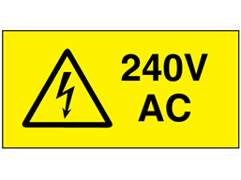
The beauty of the ManuFlo pluggable batch controller modular systems now in use for over 40 years (since 1978) is that any faulty/malfunctioning batch controller can be easily removed/swapped, via its STV pluggable connector system and replaced with a another ME-series batch controller. Without removing wires or having to call an electrician.
This rapid replacement ability has allowed countless times to troubleshoot , where the batcher needs to complete a load of concrete so that the trucks can deliver to construction sites on time.
This is increasingly important in country towns or remote sites, where rapid problem solving is required.

The plug we use is a WEIDMULLER STV series (datasheet to follow).
They are a very safe plug set and near impossible to receive an electrical shock as no bare metal is exposed.

The procedure is to simply remove the two screws, pull out the controller and then grabbing the Weidmuller plug at both ends pry apart the mating plugs.
Due to the nature of the design of the plug the chance of receiving an electric shock if following this procedure is avoided. Its been common procedure for over 40 years .

But as OH&S procedures further make their way into industry sites and procedures… we suggest the following upgrade to the ManuFlo equipment;
WE RECOMMEND sticking 240vac labels inside/outside the housing boxes and on the top of the batch controllers.
We must bear in mind we have equipment out there still in use over 40 years old that predates a lot of today’s current OH&S procedures.
So as a consequence the above procedures are recommended to satisfy any OH&S concerns.

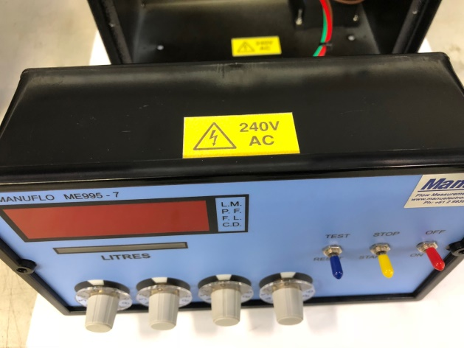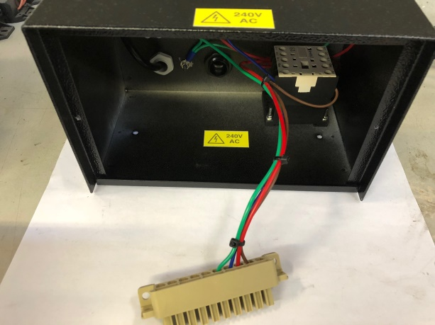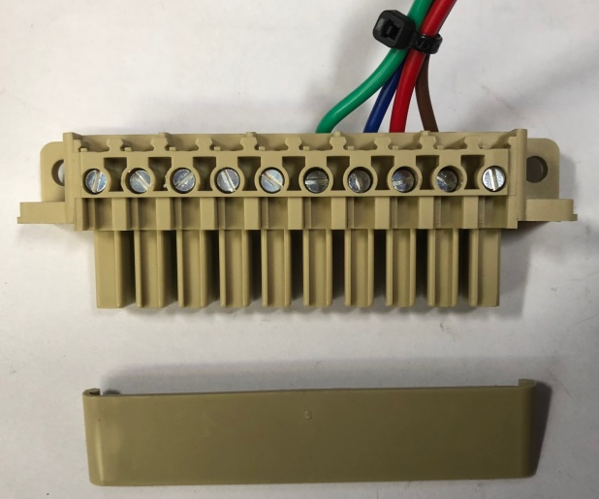 Further these extra protection clip-on covers are available.

